Nama : Andri Firman Saputra  
NIM : 201011402125  
Kelas : 05TPLP016  
Tugas : Basis Data II – Pertemuan 4

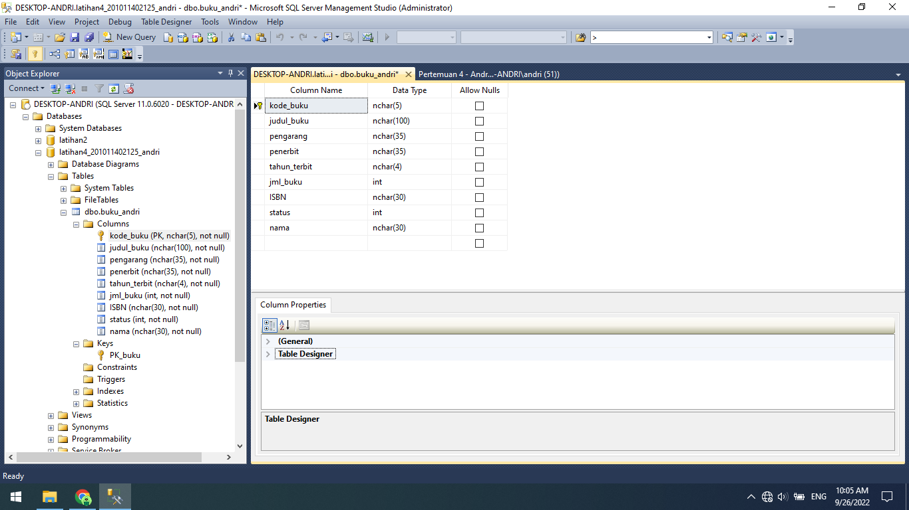

Source Code:

create database latihan1;

drop database latihan1;

create database latihan2;

create table karyawan (

nik nchar (10) not null,

nama_kar nchar(35) not null,

jk nchar(1) not null,

alamat nchar(100) null,

kota nchar(26) null

);

ALTER TABLE karyawan

ADD CONSTRAINT PK_karyawan primary key(nik);

ALTER TABLE karyawan

ADD no_telepon nchar(12) not null;

create database latihan4_201011402125_andri;

use latihan4_201011402125_andri;

create table buku_andri (

kode_buku nchar(5) not null,

judul_buku nchar(100) not null,

pengarang nchar(35) not null,

penerbit nchar(35) not null,

tahun_terbit nchar(4) not null,

jml_buku int not null

);

alter table buku_andri

add constraint PK_buku primary key(kode_buku);

alter table buku_andri add ISBN nchar(30) not null;

alter table buku_andri add _status int(1) not null;

alter table buku_andri add nama nchar(30) not null;